AVI1O5 Portfolio Assignment

Your task: A portfolio is a collection of work or the actual folder used to house a collection of work. In this course, you are being asked to create a portfolio folder to store the artwork that you create this semester. For this course, your portfolio cover should reflect your hopes, dreams, and/or goals for the future. As well, it will allow you to hone your knowledge and understanding of the elements and principles of design.

Step 1
- Select at least three elements AND three principles of design that you would like to incorporate into your portfolio design.

Step 2
- Make a list of some of your hopes, dreams, and/or goals for the future (ex. Making new friends in high school, earning a spot on the school’s basketball team, becoming a graphic artist, back-packing through Europe, etc.)

Step 3
- Complete 1-2 full page rough sketches of your portfolio design ideas.
- Remember to incorporate at least three elements and three principles of design into your rough sketch(es).
- Keep in mind: your design should centre around your hopes, dreams, and/or goals.

Step 4
- Fold a piece of Bristol board in half to create a folder.
- Transfer your best sketches onto one side of the folder.
- Your good copy could be a combination of the best sketches from your rough sketches.
- Make your design big, bold, and visually engaging.
- Try to fill up your space with images and colour that reflect your hopes, dreams, and/or goals.
- Make sure you’ve applied several elements and principles of design.

Step 5
- Write a one paragraph description of your portfolio design.
- Tell me what the images convey and what elements and principles of design you used.
- Your paragraph should be at least half a page (approx. 250 words min.)

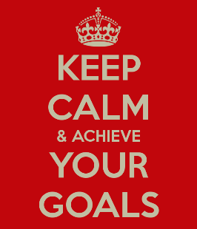

AVI1O5 Portfolio Rubric

 | Level 1 | Level 2 | Level 3 | Level 4
Knowledge & Understanding  -portfolio images demonstrate that he or she has a strong understanding of his or her hopes, dreams, and goals | -images demonstrate limited self-understanding | -images demonstrate some self-understanding | -images demonstrate considerable self-understanding | -images demonstrate a high degree of self-understanding
Thinking & Inquiry  -rough sketches reflect well developed ideas | -sketches demonstrate few well developed ideas | -sketches demonstrate some developed ideas | -sketches reflect a good number of developed ideas | -sketches reflect a number of well developed ideas
Communication  -using proper spelling and grammar  -clearly explaining hopes, dreams, and goals  -explaining all the elements and principles of design used | -describes his or her design with limited effectiveness | -describes his or her design with some effectiveness | -describes his or her design with considerable effectiveness | -describes his or her design with a high degree of effectiveness
Application  -effectively applies at least 3 elements and 3 principles of design to portfolio cover | -applies elements and principles of design with limited effectiveness | -applies elements and principles of design with some effectiveness | -applies elements and principles of design with considerable effectiveness | -applies elements and principles of design with a high degree of effectiveness
Descriptive feedback:

