AVI105 Watercolour Resist Landscape Painting

Your tasks:

Step 1
- Find a photograph of a Canadian landscape. It can be a photo that you took or one that you have found online or in a magazine.
- Tip: Find a landscape that has a good focal point (ex. A tree, mountain, etc.).

Step 2
- Create a contour line drawing of the landscape in your sketchbook. This will help you develop an awareness of the edges that define your landscape so you can be successful creating your painting.

Step 3
- Using watercolour paper and an HB pencil, create a light contour drawing of your landscape.

Step 4
- Using crayon, go over the contour line drawing.
- Examine your photo and identify the textures that are standing out to you. Using a crayon, recreate these textures on your watercolour paper.

Step 5
- Using scrap paper and watercolour paint, practice mixing and creating vibrant, bold colours that reflect the landscape you chose.

Step 6
- Paint your crayon drawing using the colours that you like the best from Step 5. Be creative with your colour selections. You can turn up the volume on the original colours in the landscape photo.
- *Please submit an image of the original landscape with your completed painting.

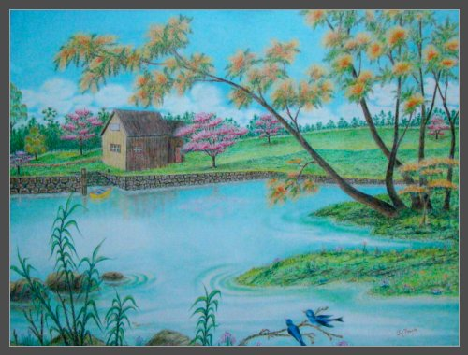

AVI1O5 Watercolour Resist Landscape Painting Rubric

 | Level 1 | Level 2 | Level 3 | Level 4
Thinking & Inquiry  -Creative interpretation of landscape is evident through colour selection | -uses creative thinking skills with limited effectiveness | -uses creative thinking skills with some effectiveness | -uses creative thinking skills with considerable effectiveness | -uses creative thinking skills with a high degree of effectiveness
Communication  -contour drawing  communicates a strong understanding of the edges that define the landscape | -contour drawing communicates the edges that define the landscape with limited effectiveness | -contour drawing communicates the edges that define the landscape with some effectiveness | -contour drawing communicates the edges that define the landscape with considerable effectiveness | -contour drawing communicates the edges that define the landscape with a high degree of effectiveness
Application  -successfully applies line, shape, texture, and colour to create a unified composition | -applies elements with limited effectiveness to create a unified composition | -applies elements with some effectiveness to create a unified composition | -applies elements with considerable effectiveness to create a unified composition | -applies elements with a high degree of effectiveness to create a unified composition

Descriptive feedback:

