

**Art Team Building Activity**

2. Why do you all enjoy visual arts? Identify 5 reasons:

3. List 3 art mediums that you all like to use. *Note: art mediums refers to the art supplies or materials you use to create art.

1. Identify one famous artist that you all admire:

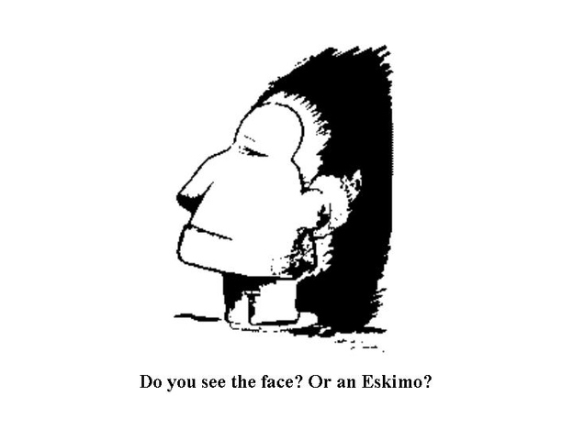5.

4. Henri Matisse once said that “creativity takes courage.” What do you think he meant by saying this?

6. Pablo Picasso once said: “Every child is an artist. The problem is how to remain an artist once we grow up.” What do you think he meant?

7. List 7 skills or characteristics that will help you all be successful this semester in this visual arts course: