Romanesque and Gothic Art

- They were moving away from the static and gold-encrusted imagery of the Byzantine style during the Gothic and Romanesque period.

- Many artists painted with egg tempra.

- 2 stylistic differences include:
- Giotto’s piece is more realistic, while the earlier piece is more flat (lacks depth).
- There is a greater sense of movement in Giotto’s piece.

- Romanesque churches were often built along pilgrimage routes and were designed to accommodate a large number of worshippers.

- The Romanesque style of architecture begins and ends from AD 1000 to the mid 12th century (1150).

- Romanesque refers to the style of architecture containing both Roman and Byzantine elements. It also refers to the Roman arch through the use of the round barrel vault.

- Sketch

- 2 architectural similarities include:
- They both have a nave.
- They both have an apse.
2 architectural differences include:
- St. Serin has a circular aisle (ambulatory)
- St. Serin has more seating along the nave (wider).

- Sketch

- The first Gothic church was the Abbey of St. Denis in France and Abbot Suger built in 1137-1144 AD.

- 2 stylistic differences include:
- There is no long transept in St. Denis.
- St. Denis appears longer and wider.

- The pointed arch and flying buttresses helped make Gothic churches taller then Romanesque churches.

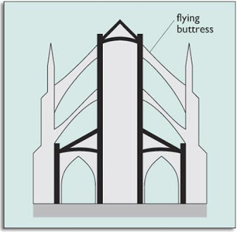

- Sketch

- During the Gothic period, stained glass was used quite frequently.

- There is one central figure in the centre who is seated on what looks like a throne. The figures on the left are grouped together and seem peaceful. There appears to be move movement and chaos on the left side (figures in action).

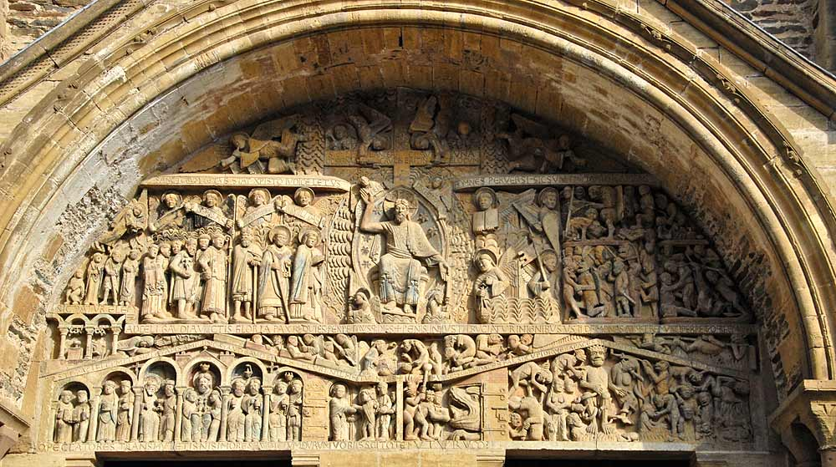

- Half the figures have been placed in a structure. These figures are all under arches and in between pillars. It creates a sense of order, balance and peace. The other figures are in a structure but are climbing on top of each other. This creates some chaos, movement, and instability.

- The figures are arranged in a triangular shape. The figures become smaller around the edges. Each person seems to be engaged in some activity. It creates a sense of balance, movement, and order.

- Gargoyle comes from the Latin word for “gurgulio,” meaning “throat” and the “gurgling” sound water makes as it passes through a gargoyle. A carved creature that does not serve the purpose of a drain pipe is frequently referred to as “Grotesque.”

