AVI2O Exam Review
Picture Recognition: You will need to apply your knowledge of art history for part of the final exam. You must be able to identify the name of each monument, structure, or type of art that is featured on the exam. You must also be able to identify the name of the art history period each featured monument/artwork is associated with. Test your knowledge by completing the chart below.
Monuments, structures, and art forms you need to know: | Identify the name of each monument, structure, and art form: | Identify the art history period each monument, structure, and art form is associated with:
1 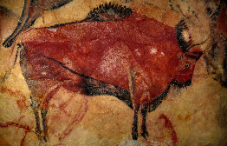
2 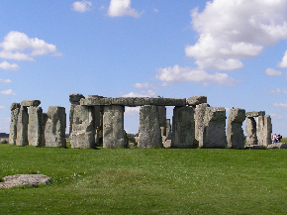
3 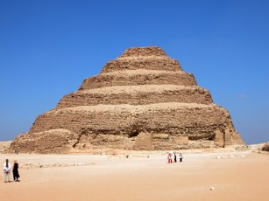
4 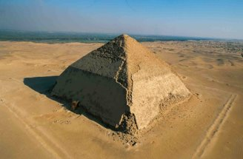
5 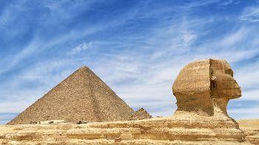
6 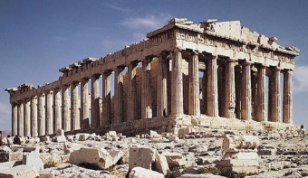
7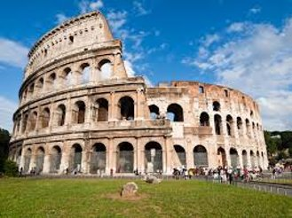
8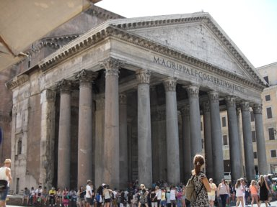
9 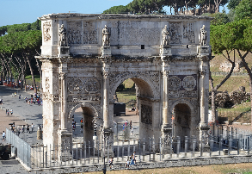
10 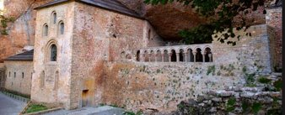
11 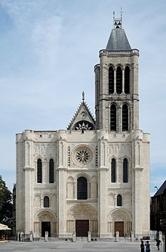
12 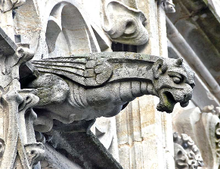
Terminology: You should know the meaning of the following terms from Prehistoric Times and Ancient Egypt: Paleolithic Period, megalith, post-lintel construction, ziggurat, cuneiform writing, stele, pharaoh, dynasty, sarcophagus, mastaba, Step pyramid, Bent pyramid, Great Pyramid, ka, and hieroglyphics. Note: You should still have the review from our 1st art history unit. Please use that review to study the terms from Prehistoric Times and Ancient Egypt. Use the chart below to refresh your memory of the most recent art history terms.
Term | Meaning | Term | Meaning
The Parthenon |  | The Acropolis
Doric Order |  | Ionic Order
Corinthian Order |  | Mural
Aqueduct |  | The Baths
The Colosseum |  | Gladiator
The Pantheon |  | Constantine
Triumphal Arch |  | Nave
Apse |  | Hagia Sophia
Catacombs |  | San Vitale
Charlemagne |  | Feudalism
Monasticism |  | Transept
Romanesque |  | Gargoyle
The Elements and Principles of Design
- You should be able to identify and describe the elements and principles of design, especially when you examine a work of art.
- As well, be prepared to answer multiple choice, matching, and true/false questions that pertain to the elements and principles of design.
Adding value
- You should know the different ways we can create value and depict light/shadows.
- Examples include: hatching, cross-hatching.

Surrealism
- You should know the origins and main aims/goals of Surrealism.
- You should also know related movements: Dadaism and Automatism.
Colour theory
- Know the properties of colour
- Know the difference between primary, secondary, and tertiary colours
- Know the difference between tint and shade
- Know the meaning of monochromatic, analogous colours, and complementary colours.

Additional Art History Information to Review
Prehistoric Times  -The Lascaux Cave  -The cave paintings of Altamira  -Paintings and hunting rituals  -Stonehenge: its history and significance  -The Sumerian peoples & their connection to Mesopotamia  -The Akkadian Period  -The Neo-Sumerian Period | Ancient Egypt  -The Old Kingdom, The Middle Kingdom, and the New Kingdom  -Who temples were dedicated to  -The evolution of Egyptian tombs and pyramids (Tip: review the characteristics of each pyramid)  -Why sculptors would carve the pharaoh’s portrait and where it was placed  -Rules followed by Egyptian artists | Ancient Greece  -The characteristics of Ancient Greek temples  -The purpose of vases  -Uses for sculptures and the characteristics of sculptures during the Archaic Period, the Classical Period, and the Hellenistic Period
Ancient Rome  -The Greek influence on Ancient Rome  -Greek vs Roman sculptures  -Why murals were painted and what was often depicted on murals  -Characteristics of Roman temples  -Roman innovations (ex. Their use of concrete)  -Know the history of the Colosseum and the nature of gladiator fights  -Know Constantine, his vision before the battle of the Milvian Bridge, what he ordered his troops to paint on their shields, and why he granted religious freedom to Christians  -The original purpose of Roman basilicas and the characteristics of Roman basilicas | The Byzantine Empire  -The best examples of the Byzantine style  -The structure of the Hagia Sophia and why mosaics were used within it  -The characteristics of art found within Byzantine churches | Medieval Times  -What started the Early Medieval period  -How this was a faith-based society  -Charlemagne’s impact- major accomplishments  -Characteristics of medieval churches and monasteries  -The Monastery of San Juan de la Pena  -Know what many artists during the Gothic period began painting with  -Where Romanesque churches were often built  -The characteristics of Romanesque and Gothic churches  -Know the Abbey of St. Denis  -Romanesque vs Gothic sculptures

