AVI2O Scratchboard Art

In the Prehistoric era and the Ancient Egyptian period, art was frequently created through scratching and carving on various surfaces. As we near the end of our first art history unit, you will create a work of art using this ancient technique. Specifically, you will be creating your next work of art on scratchboard. Please review the expectations below before you begin this new project.

Steps to Success:

- Select ONE image of a person, animal, object, or landscape that has interesting and well-defined textures, shadows, and highlights (ex. A lion’s face, a forest scene, a bearded human face, etc.).
- In your sketchbook or on a blank sheet of white paper, create a fully rendered graphite sketch of your chosen image. This should NOT be a simple contour line drawing. It should include all the edges, spaces, textures, shadows, and light that define your subject matter.
- Using a black sheet of bristol board or construction paper as well as a white pencil crayon or piece of chalk, practice hatching, cross-hatching, and stippling. As well, practice creating the lighter values and textures that define your subject matter.
- Using a light graphite pencil, create a contour line drawing of your concept on the scratchboard or use the saral paper to transfer an outline of your image to the scratchboard. *Note: If you are using saral paper, you will need to create a contour line drawing of your concept on a blank sheet of paper. Please see me for further instructions if you are using the saral tracing method.
- Using the etching tool(s) provided, begin scratching your concept onto the scratchboard.
- Submit a copy of the original image you used to D2L when you are ready to submit your entire project.
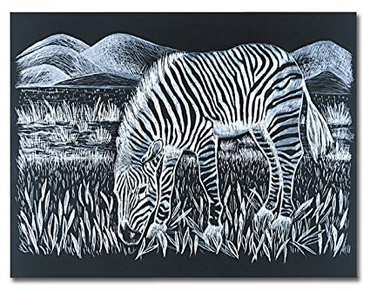Due date: _____________________________________

AVI2O Scratchboard Sketch Rubric

 | Level 1 | Level 2 | Level 3 | Level 4
Application: The student applies proper graphite drawing techniques to successfully capture the defining features of their subject matter. | -applies graphite drawing techniques with limited effectiveness | -applies graphite drawing techniques with some effectiveness | -applies graphite drawing techniques with considerable effectiveness | -applies graphite drawing techniques with a high degree of effectiveness

AVI2O Scratchboard Rubric

Achievement Categories | Level 1 | Level 2 | Level 3 | Level 4
Knowledge & Understanding: The student’s scratchboard art demonstrates that he or she has a strong understanding of the elements and principles of design. | -demonstrates a limited understanding of the elements and principles of design | -demonstrates some understanding of the elements and principles of design | -demonstrates a considerable understanding of the elements and principles of design | -demonstrates a thorough understanding of the elements and principles of design
Communication: The student successfully communicates the defining features of the person, animal, object, or scene on his or her scratchboard. | -communicates the subject matter with limited effectiveness | -communicates the subject matter with limited effectiveness | -communicates the subject matter with limited effectiveness | -communicates the subject matter with limited effectiveness
Application: The student  successfully applies various etching techniques when creating his or her scratchboard art (ex. Hatching, cross-hatching, etc.). | -applies etching techniques with limited effectiveness | -applies etching techniques with some effectiveness | -applies etching techniques with considerable effectiveness | -applies etching techniques with a high degree of effectiveness

