AVI2O: Zentangle® Portfolio Cover Project
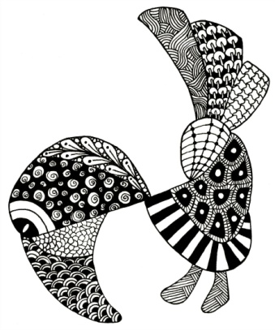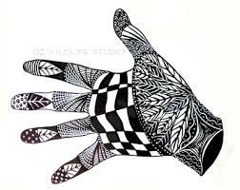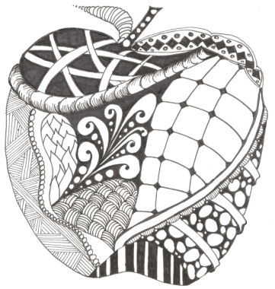
What is a Zentangle?
Zentangle - A Zentangle is an abstract drawing created by using repetitive patterns. It is usually structured within a certain shape. Drawing a Zentangle is entertaining, relaxing, and a great way to express yourself creatively.
String - A string is generally a random line drawn in pencil which creates an area within which you draw your tangles.
Tangle - In its verb form “tangle” means to draw a tangle. You tangle a tangle, and in that process create Zentangle art. In its noun form this word is used as a replacement for “pattern.”

For more information about the Zentangle process, go to www.Zentangle.com
Instructions:
- Brainstorm different shapes you could use as the outline or frame of your Zentangle. You will want to choose something recognizable (ex. a whale, a hand, etc.).
- Next, create at least 8 different tangles (patterns) that you will incorporate into your design. Each tangle should combine 1 element and 1 principle of design. Use the design matrix to create your tangle/pattern ideas. You may take some of your ideas from previously created tangles but try to develop as many original tangles as possible.
- On your portfolio cover, draw the shape that you have selected to frame your Zentangle.
- Draw in some “strings” to fit your “tangles” into. These lines can be random, or they can help make your frame into a recognizable object, like the eyes and feathers of the bird above.
- Incorporate at least 8 patterns from your design matrix to use in your Zentangle. If you have lots of spaces, you may repeat your patterns or create a few additional patterns. Think about balance and unity when filling in your design. You may use pencil crayons if you decide to apply the element of colour for some of your tangles.
- When your Zentangle is complete, go over everything with black pen, India ink, or a sharpie.

Rubric Zentangle® Portfolio Cover Project
 | Level 1 | Level 2 | Level 3 | Level 4
Knowledge and Understanding | Zentangle portfolio cover design demonstrates limited knowledge of the elements and principles of design | Zentangle portfolio cover design demonstrates some knowledge of the elements and principles of design | Zentangle portfolio cover design demonstrates considerable knowledge of the elements and principles of design | Zentangle portfolio cover design demonstrates thorough knowledge of the elements and principles of design
Thinking and Inquiry | Design matrix demonstrates limited planning  Tangles (on portfolio cover) demonstrate limited creativity and effort | Design matrix demonstrates some planning  Tangles (on portfolio cover) demonstrate some creativity and effort | Design matrix demonstrates considerable planning  Tangles (on portfolio cover) demonstrate considerable creativity and effort | Design matrix demonstrates thorough planning  Tangles (on portfolio cover) demonstrate a high degree of creativity and effort
Communication | Communicates a recognizable shape with limited effectiveness when framing his or her tangles | Communicates a recognizable shape with some effectiveness when framing his or her tangles | Communicates a recognizable shape with considerable effectiveness when framing his or her tangles | Communicates a recognizable shape with a high degree of effectiveness when framing his or her tangles
Application | Applies the art of Zentangle with limited effectiveness on portfolio cover design | Applies the art of Zentangle with some effectiveness on portfolio cover design | Applies the art of Zentangle with considerable effectiveness on portfolio cover design | Applies the art of Zentangle with a high degree of effectiveness on portfolio cover design

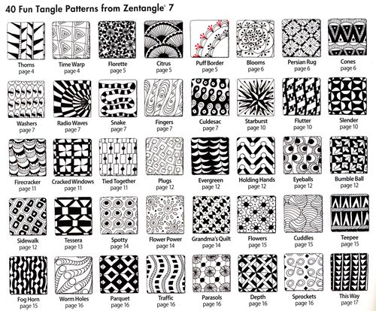

“40 Fun Zentangle Patterns from Zentangle 7.” November 15, 2014. Retrieved from: http://www.kalinkas-blog.de/zentangles-mit-kleinen-mustern-zu-schoenen-bildern/

