AVI3M Photorealism Project: The Human Face

Your task: This is a drawing assignment that requires you to create a large, realistic drawing of a human face. Specifically, it calls you to explore photorealism. Photorealism is “a style of painting or drawing in which images look so real that they are hard to distinguish from photographs” (Macmillan Dictionary). This project asks you to create a drawing that looks strikingly similar to the original photo it was based on.

Step 1
- Select a photo of a human face and print it off in black and white. It should be large enough that you can see all the details clearly and potentially add a grid.
- The photo can be one that you have taken of your own face or someone else’s face. You could also select a photo online or in a magazine that depicts someone you admire (ex. a celebrity).

Step 2
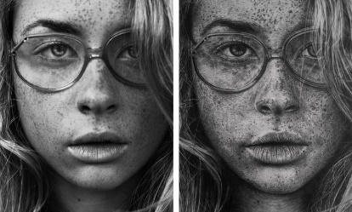
- Decide whether or not you will use a grid to help you reproduce the photo on the drawing paper in the right proportions.
- Your drawing should be at least 12 inches (width) by 16 inches (length) with an additional 1-2 inches for a border.
- You may need to cut your drawing paper.

Step 3
- If you chose the grid method: Draw a grid on your original photo and then draw a light grid on your drawing paper. On your drawing paper: you will likely have to increase the size of your original grid (ex. go from 1 inch boxes to 2 inch boxes).
- Create a light contour drawing of the face on your drawing paper.
- Make adjustments to your contour drawing as necessary. *You want it to look right from a proportional standpoint.

Step 4
- Review the handout, “Drawing from the right side of the brain.” (Perceptual skills)
- Add texture and value to your drawing. Capture where the light is hitting the face.
- You will likely have to use different pencils to achieve certain effects.

Step 5
- In a well-developed paragraph, explain how you used the elements and principles of design to create your drawing.
- Your paragraph should be at least 250 words.
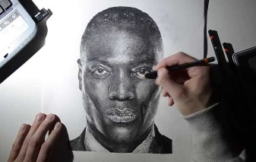

AVI3M Photorealism Rubric

 | Level 1 | Level 2 | Level 3 | Level 4
Knowledge & Understanding  -drawing demonstrates a strong understanding of the elements and principles of design | - drawing demonstrates a limited understanding of the elements and principles of design | - drawing demonstrates some understanding of the elements and principles of design | - drawing demonstrates a considerable understanding of the elements and principles of design | - drawing demonstrates a thorough understanding of the elements and principles of design
Thinking & Inquiry  -demonstrates good planning and time management skills when completing the project | -uses planning and time management skills with limited effectiveness | -uses planning and time management skills with some effectiveness | -uses planning and time management skills with considerable effectiveness | -uses planning and time management skills with a high degree of effectiveness
Communication  -written description effectively explains how he or she used the elements and principles of design to create the drawing | -communicates how he or she used the elements and principles of design with limited effectiveness | -communicates how he or she used the elements and principles of design with some effectiveness | -communicates how he or she used the elements and principles of design with considerable effectiveness | -communicates how he or she used the elements and principles of design with a high degree of effectiveness
Application  -applies the 5 perceptual skills with a high degree of effectiveness (perception of edges, spaces, relationships, lights & shadows, and the whole) | - uses the 5 perceptual skills with limited effectiveness | - uses the 5 perceptual skills with some effectiveness | - uses the 5 perceptual skills with considerable effectiveness | - uses the 5 perceptual skills with a high degree of effectiveness

