AVI3M Sketchbook Assignment

Your task: Throughout this semester you will be completing a sketchbook assignment. This project will allow you to hone your creativity and drawing skills. It will also give you the chance to practice using the elements and principles of design. For this sketchbook assignment, you are required to submit 2 sketches at the end of each month (with the exception of January). You must select topics from the list of sketchbook ideas below. You should either use pencil or pencil crayon.

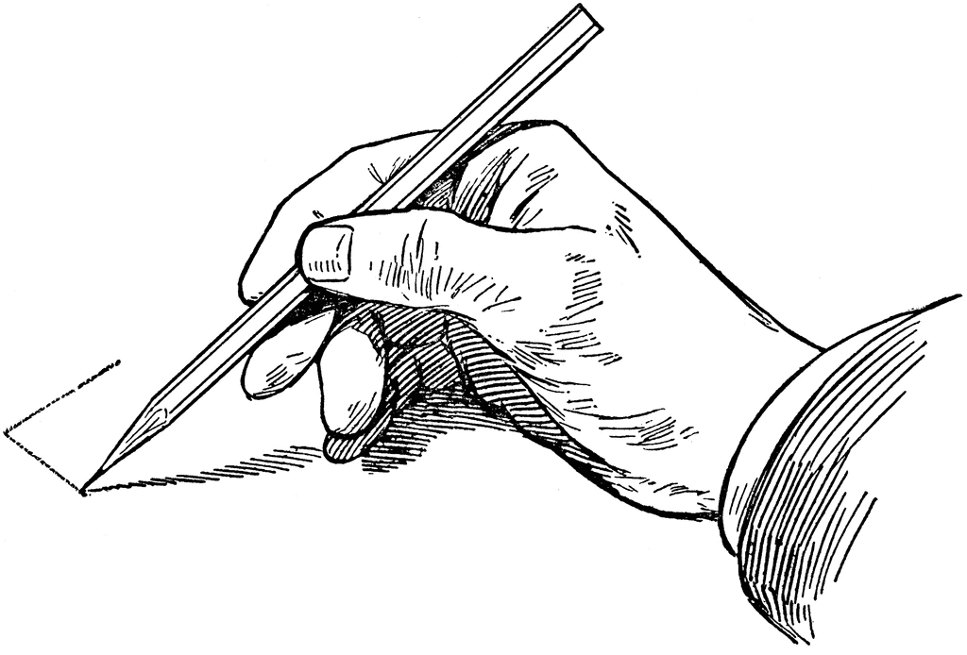
Sketchbook ideas:
- Create a new superhero
- Design a new logo for one of your favourite companies
- Draw a landscape based on a photo you have taken or found online
- Design a tattoo
- Draw an animal in its natural habitat
- Draw a scene from one of your favourite places you have travelled to
- Cut out part of a photo from a magazine and glue it into your sketchbook. Draw in the rest of the photo.
- Design a futuristic car
- Draw a plant
- Draw a scene in a restaurant
- Create a drawing of a sculpture
- Draw a mythical creature (ex. Dragon)
- Pretend that you are a fashion designer. Draw a model with an outfit centred on a theme (ex. An outfit for a celebrity attending the 2018 Met gala – theme: “Heavenly bodies: Fashion and the Catholic Imagination”).
- Draw a face from a photo
- Draw your favourite pet
- Draw an object or symbol that you associate with good luck
- Draw a renaissance drawing by an artist you admire from that time period
- Create a still life drawing of something in your home (ex. Bowl of fruit)
- Draw an exotic creature (ex. Exotic fish)
- Draw your biggest hope or dream for the future
- Draw an object three times in different lighting
- Draw a cubist portrait

Due dates:
September: _______________________
October: _________________________
November: _______________________
December: _______________________

AVI3M Sketchbook Rubric

 | Level 1 | Level 2 | Level 3 | Level 4
Knowledge & Understanding  -Each sketch demonstrates a strong understanding of the elements and principles of design | -demonstrates a limited understanding of the elements and principles of design | -demonstrates some understanding of the elements and principles of design | -demonstrates a considerable understanding of the elements and principles of design | -demonstrates a thorough understanding of the elements and principles of design
Thinking & Inquiry  -Each sketch demonstrates strong creative thinking skills | -uses creative thinking skills with limited effectiveness | -uses creative thinking skills with some effectiveness | -uses creative thinking skills with considerable effectiveness | -uses creative thinking skills with a high degree of effectiveness
Application  -Each sketch is a successful application of the elements and principles of design | -applies the elements and principles of design with limited effectiveness | -applies the elements and principles of design with some effectiveness | -applies the elements and principles of design with considerable effectiveness | -applies the elements and principles of design with a high degree of effectiveness

