Causes of the Great Depression

What was the Great Depression?
- The Great Depression lasted from _________________ and was the worst economic disaster to hit the modern world.
- ______________ of people suffered as they lost their ______ and living conditions ___________________.

MAJOR IMMEDIATE CAUSES

1. The Stock Market Crash of 1929
- The Great Depression was triggered by this collapse of the market on _____________________________.
- It became known as “_________________.”
- ______________________ collapsed in the U.S. and Canada.
- Investors realized that their shares were _________________ and tried to ______ them all at once.
- _____________________ shares were traded and lost _______ their value ($9 billion)
- Many investors lost all savings and went _________________.

2. Prairie Drought of 1929
- The drought lasted for ________________.
- A __________________ plague destroyed many crops.
- A lack of _______ turned sections of the west into _________________.
- The economies of ______________ and ____________ suffered as the farmers could no longer afford to buy _____________ goods.
- While prairie farmers were struggling to survive, Australia, Russia, and Argentina had _________________________.
- This forced the price of wheat down from $1.29/bushel in 1928 to _______________ in 1932.
- Things went back to normal by 1939, but 250, 000 farmers had ____________________ their farms in the West and went __________________ throughout Canadian cities.

Dust Bowls
- A dust bowl is “an area of land where __________________ has been lost and soil reduced to ________ and eroded, especially as a consequence of drought or unsuitable farming practice.”

MAJOR UNDERLYING CAUSES

1. Natural Resources
- Canada’s economy depended on the _________________ to other countries, mainly to the U.S., and _____________________ made up most of these exports.
- ____________________________________________ made Canada prosperous.
- The good times ____________________________________________________.

2. Buying on Credit
- Buying on credit became very popular in the 1920s (spending money that you do not have).
- Most people and businesses in the 1920s were overly ____________________
____________________________.
- Farmers, businesses, and individuals _____________________________ as long as they could afford to make their ________________________________.
- Some people bought shares of _____________________ on credit.

3. Overproduction of Goods
- Many businesses ___________________ their goods in warehouses in the 1920s.
- There was not ________________________ for all the products.
- Businesses bought more ______________ and hired more _____________ for the factories in the 1920s.
- Farmers purchased more _______ as they were optimistic like everyone else about the future.

4. High Tariffs
- To protect Canadian businesses and their workers, the government ___________ tariffs on ________________________.
- Other countries also raised tariffs and this resulted in less trade and __________
_____________________________________________.
- Demands for goods from Canada began to _____________________, and Canadian workers were _______ off.
- The tariff increase further _______________ economies.

What do you think the message is behind this political cartoon?

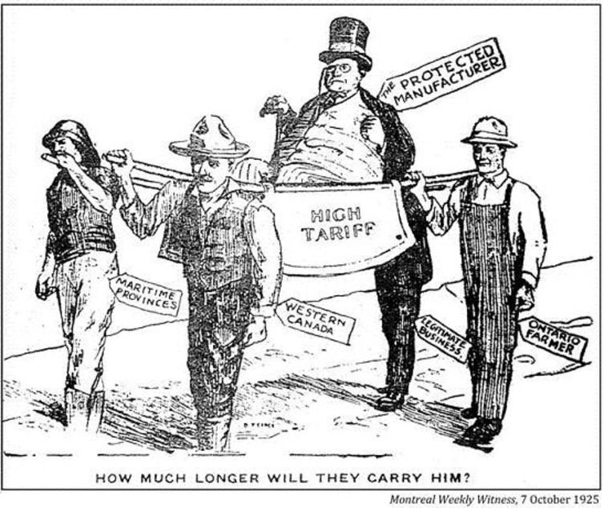
______________________
______________________
______________________
______________________
______________________
______________________
______________________
______________________
______________________
______________________
______________________
______________________
______________________
______________________
______________________
______________________

5. Low Incomes of Some Canadians
- Contrary to belief, ______________________________ shared in the prosperity of the 1920s.
- Some people remained in ____________________________ and had ______
______________________________________.
- Farmers who did not produce grain did not receive high prices for their crops.
- Some regions, such as the Maritimes, did not share in the _________________
_____________________________________.
- All of these factors _______________ the demand for Canadian goods and services.

Summary
- All of these factors played a role in the causes of the Depression.
- The collapse of the _____________________ made companies realize that they had overspent and overproduced.
- The results were _______________________ and ______________________ in the economy.
- People could not meet ______________________ and lost houses, cars, appliances, etc.
- There was less money to __________ and the economy went _______________.

