CHC2D WW2 Infographic

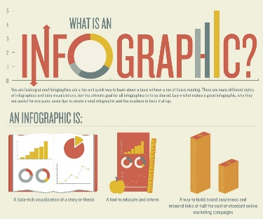
Your task: This assignment requires you to become familiarized with one of the major battles of World War 2. Specifically, you will be creating an infographic to show your understanding of the battle you are assigned. You may complete the assignment individually or with a partner.

Steps to Success:

Step 1
- Through a draw, you will be assigned one of the following battles:
- The Battle of Britain
- The Battle of the Atlantic
- The Dieppe Raid
- The Invasion of Normandy (D-Day)
- The Liberation of the Netherlands
- The Invasion of Italy
- Note: You may switch topics with another student in the class if that student is okay with it.

Step 2:
- Research the battle you were assigned.
- Essentially, you should gather enough information so you can answer the 5W’s and 1 H:
- Who was involved?
- What happened?
- Where did the battle occur?
- When did the battle occur?
- Why did the battle take place?
- How did the battle shape the outcome of the war?
- Look for images as well. Images will help your infographic stand out more.
- Consider visiting the following sites/sources of information:
- https://www.canada.ca/en/services/defence/caf/militaryhistory/wars-operations/wwii/battles-campaigns.html
- http://www.worldatlas.com/articles/major-battles-of-world-war-ii-ww2.html
- The Canadian Encyclopedia (accessed through the Library page)
- EBSCO (accessed through the Library page)
Step 3:
- Use the information and images you have gathered to make an infographic.
- Your infographic can take the format of an 8 1/2 x 11 inch page or be in the form of a brochure. Either way, make it CREATIVE.
- Infographics “can help you simplify a complicated subject or turn an otherwise boring subject into a captivating experience. Ideally, an infographic should be visually engaging and contain a subject matter and data that is appealing to your target audience …something that is truly ‘link worthy’ or ‘share worthy’.” (https://www.customermagnetism.com/infographics/what-is-an-infographic/)
- Try googling sample infographics to get a visual perspective of them.

Step 4:
- Submit a copy of your infographic by ____________ through D2L or in hard copy format.
- Please include a bibliography in the Chicago format. ***Consult 2-3 sources.

 | Level 1 | Level 2 | Level 3 | Level 4
Knowledge & Understanding | -demonstrates a limited understanding the battle | -demonstrates some understanding the battle | -demonstrates a considerable understanding the battle | -demonstrates a thorough understanding the battle
Thinking and Inquiry | -uses creative skills with limited effectiveness | -uses creative skills with some effectiveness | -uses creative skills with considerable effectiveness | -uses creative skills with a high degree of effectiveness
Communication | -organizes and expresses information with limited effectiveness | -organizes and expresses information with some effectiveness | -organizes and expresses information with considerable effectiveness | -organizes and expresses information with a high degree of effectiveness
Application | -follows the Chicago format with limited effectiveness | -follows the Chicago format with some effectiveness | -follows the Chicago format with considerable effectiveness | -follows the Chicago format with thorough effectiveness

