CHC2D WW1 Battle Newscast Assignment

Steps to Success

Step 1:
- Find a group of people to work with.
- Your group should have a minimum of 3 members and a maximum of 5 members.

Step 2:
- As a group, identify the top 3 WW1 battles that you are interested in researching.
- Note: A draw will take place to determine what battle your group researches. The first group to be drawn will get their top pick.
- Your group may pick from the following battles:

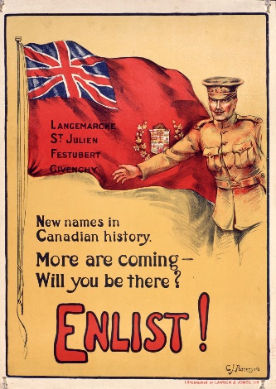
- The Battle of 2nd Ypres
- The Battle Vimy Ridge
- The Battle of Somme
- The Battle of Passchendaele
- The Battle of Amiens

Step 3:
- Research the battle that your group was assigned.
- Each group must answer the following questions:
- When did the battle occur?
- Who was involved?
- What happened?
- Why was the battle important for Canada?
- How was the battle important to the overall war?

- Consider using the following website to begin your research:
- http://ww1.canada.com/battlefront/five-major-canadian-battles-of-the-first-world-war

Step 4:
- Develop a skit in the form of a newscast to teach your classmates about the battle.
- All of the questions from Step 3 must be answered at some point during your skit.
- Be CREATIVE as you develop your skit.
- All members of the group need to have a speaking part in the skit.
- Your skit should be a minimum of 5 minutes and a maximum of 10 minutes.
- Note: You do not have to have all of your lines memorized but you do need to be able to make regular eye contact and speak clearly.
- On the day of your presentation, please submit:
- A copy of your script
- A bibliography in the Chicago style format

Rubric

 | Level 1 | Level 2 | Level 3 | Level 4
Knowledge & Understanding: All 5 of the questions must be answered thoroughly and correctly. | - he or she demonstrates limited knowledge of the WW1 battle | - he or she demonstrates some knowledge of the WW1 battle | - he or she demonstrates considerable knowledge of the WW1 battle | -he or she demonstrates thorough knowledge of the WW1 battle
Thinking & Inquiry: The skit must be creative and engaging. | - uses his or her creative abilities with limited effectiveness | - uses his or her creative abilities with some effectiveness | - uses his or her creative abilities with considerable effectiveness | - uses his or her creative abilities with a high degree of effectiveness
Communication: Each student must make eye contact with their audience, speak clearly, and demonstrate confidence. | - he or she orally expresses ideas and information with limited effectiveness | - he or she orally expresses ideas and information with some effectiveness | - he or she orally expresses ideas and information with considerable effectiveness | - he or she orally expresses ideas and information with a high degree of effectiveness
Application: The student cites his or her sources using the Chicago format. | - cites sources using the Chicago format with limited effectiveness | - cites sources using the Chicago format with some effectiveness | - cites sources using the Chicago format with considerable effectiveness | - cites sources using the Chicago format with a high degree of effectiveness
Descriptive feedback:

