Key Government Positions in Canada

Part A: Canada’s Federal Government

1. The Prime Minister
- Visit the following website: https://thecanadaguide.com/government/the-prime-minister/
- Read and summarize the P.M.’s responsibilities in the space provided.
- Hint: the blue subtitles give you a good indication of the P.M.’s key duties.

2. The Governor General
- Visit the Governor General’s website: https://www.gg.ca/en
- Click on “Role” and then “Responsibilities”
- Read and then summarize the Governor General’s responsibilities in the space below:

3. Senators
- Visit the following website: https://thecanadaguide.com/government/the-senate/
- Read the section titled, “What does the Senate of Canada do?” and then summarize the Senate’s duties in the space below:

4. Members of Parliament (MPs)
- Visit the website: https://lop.parl.ca/about/parliament/guidetohoc/role-e.htm
- Read and summarize the role of a Member of Parliament below:

5. The Canadian House of Commons
- Visit the website: https://lop.parl.ca/about/parliament/guidetohoc/who-e.htm
- View the diagram of the House of Commons and then label each numbered section in the chart below.

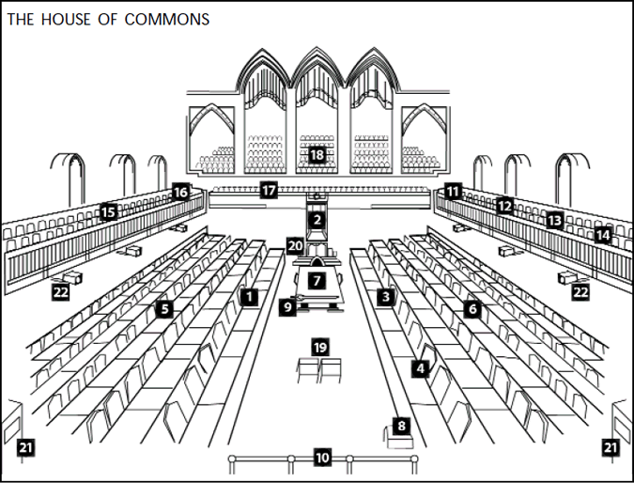
1 | 7 | 13 | 19
2 | 8 | 14 | 20
3 | 9 | 15 | 21
4 | 10 | 16 | 22
5 | 11 | 17
6 | 12 | 18

Part B: The Provincial Governments of Canada

1. Premier
- Visit the website: https://www.ola.org/en/photo/premier
- Read the description of the premier’s duties and then summarize them below:

2. The Lieutenant Governor
- Visit the website: https://www.ola.org/en/photo/premier
- Click on “Parliamentary Roles” and then “Lieutenant Governor.”
- Read and summarize the responsibilities of the Lieutenant Governor of Canada below:

3. Members of Provincial Parliament
- Visit the website: https://www.ola.org/en/photo/premier
- Click on “Parliamentary Roles” and then on “Members of Provincial Parliament.”
- Read and summarize the responsibilities of the MPPs below:

