CHV2O Voting Age Infographic
Steps to Success

- Get informed
- You are being called to take a stand – either support lowering the voting age to 16 or support maintaining the current voting age of 18.
- To make an informed decision, you must learn about the arguments that support both sides of the debate.
- Visit media sites like the CBC and the London Free Press to understand the various points of view on the matter.
- Jot down the information and perspectives that stand out to you and make note of where you attained this information.

- Make a decision
- After becoming informed on the issue, make an educated decision about your personal standpoint on the matter.

- Visually display your opinions
- Using Piktochart (or another free infographic website), create an infographic that captures and justifies your opinion on the question of whether the voting age should be lowered to 16.
- What are infographics? According to Daniel Adams from instantShift (2011), infographics are “visual presentations of information that use the elements of design to display content. Infographics express complex messages to viewers in a way that enhances their comprehension. Images are often an extension of the content of a written article, but infographics convey a self-contained message or principle.”
- Your infographic should include the following:
- A bold title: Your title should inform the viewer of what side of the debate you have taken.
- Facts and opinions: You should include a minimum of 5 – 10 facts and/or perspectives that justify your opinion.
- Images: You should include symbols or pictures that reinforce your point of view on the issue.

- Create a bibliography
- Create a bibliography in the MLA style that identifies where you gathered your facts and perspectives.
- This bibliography should not appear on your infographic – create it on a separate document.

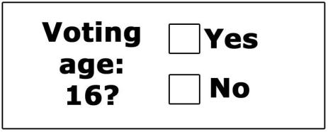

CHV2O Infographic Rubric

 | Level 1 | Level 2 | Level 3 | Level 4
Knowledge & Understanding: The student uses relevant facts and perspectives to justify his or her personal stance on the question of whether the voting age should be lowered to age 16. | -infographic demonstrates a limited understanding of their chosen point of view | -infographic demonstrates some understanding of their chosen point of view | -infographic demonstrates a considerable understanding of their chosen point of view | -infographic demonstrates a thorough understanding of their chosen point of view
Thinking and Inquiry: The student uses his or her creative thinking skills with a high degree of effectiveness when designing their infographic. | -uses creative thinking skills with limited effectiveness | -uses creative thinking skills with some effectiveness | -uses creative thinking skills with considerable effectiveness | -uses creative thinking skills with a high degree of effectiveness
Communication: The student organizes their content in a logical format on their infographic. | -organizes content with limited effectiveness | -organizes content with some effectiveness | -organizes content with considerable effectiveness | -organizes content with a high degree of effectiveness
Application: The student successfully applies the MLA style to their bibliography. | -applies the MLA style with limited effectiveness | -applies the MLA style with some effectiveness | -applies the MLA style with considerable effectiveness | -applies the MLA style with a high degree of effectiveness

