HOW DO I LOOK UP A SCRIPTURE PASSAGE?
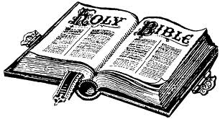

BOOKS
- THE CATHOLIC BIBLE IS A COLLECTION OF 73
CHAPTERS
- EACH BOOK IS DIVIDED INTO
VERSES
- EACH CHAPTER IS DIVIDED INTO

- Each scriptural reference gives you all the information you need to find a particular passage in the Bible.

Genesis 1:31

Verse #
Chapter #
Book Title

- Therefore, the reference Genesis 1:31 tells us to read the Book of Genesis, Chapter 1, Verse 31.

