HRE1O
______________________________________________________________

Understanding Love
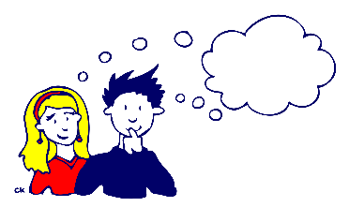
What Separates Love from Other Relationships?

- Love: characterized by _________________, _________________ acceptance, deep _________, and _______.
- Infatuation: involves ______________ feelings, feelings of deep sexual _____________. It is a relationship that could end quickly.
- Friendship: between any _____ persons who trust each other and like to spend ________ together.
- Exploitation: based on _______________ and lack of __________ for the other person.

Types of Abuse

- Psychological: Involves various tactics to ____________ an individual’s self-_______________ such as yelling, insults, threats, humiliation, or isolation.
- Physical: The most obvious, ranges from ______________ and shoving to hitting, beating, ___________ abuse with a weapon, torture, mutilation and murder.
- Sexual: Any form of non-______________ sexual activity, ranging from harassment, unwanted touching, to rape.
- Financial: tactics used to _________ an individual’s finances, inheritance, or employment income. It may include ____________ access to one’s own financial records and knowledge about personal investments, income, or debt, or ____________ a partner to take employment outside the home.
- Spiritual: attempting to destroy an individual’s ___________ or religious __________ through ridicule or punishment, forcing someone to practice a religion, or adopt another one.

The Cycle of Abuse

1. Tension-building: The abuser __________ the other partner using insults and other verbal attacks. The victim tries to be ___________ and feels ___________.
2. Violent episode: Built-up __________ erupt into incidents ranging from severe verbal/emotional abuse to physical/sexual abuse and can last from a few _________ to a few ______. The victim is most likely to be ____________ injured or killed by the abusive __________ at this time.
3. Honeymoon stage: Following a ___________ episode the abuser is usually _____________ and _____________. The victim once again ______________ the person he or she fell in love with. The victim may accept promises from the abuser that “it will _________ happen again.”

