HRE2O – Ms. Williams
Humanity Assignment

Your tasks:
1. Choose one person who you believe is or was an excellent model of the kind of human God calls us to be. Consider selecting someone from the following list (*Note: Not everyone can research the same person):

- Nelson Mandela - Desmond Tutu
- Martin Luther King - Saint Andre Bessette
- Malala Yousafzai - Romeo Dallaire
- Craig Kielberger - K’naan
- Mahatma Gandhi - Jean Vanier
- Rosa Parks - Stephen Lewis
- Pope Francis - Mary Jo Leddy
- Mother Teresa - Naomi Klein
- 14th Dalai Lama - Naomi Bronstein
- Helen Keller - David Suzuki
- Angelina Jolie - Rick Hansen
- Bono - Jimmy Carter
- Nellie McClung - Terry Fox
- Al Gore - Pope John Paul II

2. Review the following list of human qualities. Identify two of these qualities that you believe the person you selected possesses or possessed.

- Remembers that everyone was made in the image and likeness of God
- Uses his/her talents and abilities for good
- Is a steward of creation
- Shows gratitude
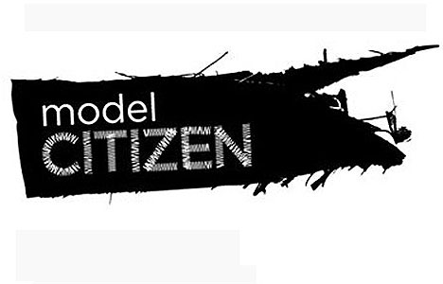
- Demonstrates generosity
- Loves God and/or neighbour
- Considers how his/her choices impact others
- Acts with the intention to do good
- Acts upon his/her emotions in a positive way
- Listens to his/her conscience
- Shows forgiveness
- Owns up to his/her mistakes

3. Find a creative way to show and explain how the individual possesses or possessed the 2 qualities you identified (eg. poster, brochure, slideshow, Prezi, article). You must write a min. of 2 paragraphs (1 about each quality) and use images or symbols.

Rubric for Humanity Assignment

 | Level 1 | Level 2 | Level 3 | Level 4
Knowledge & Understanding | Demonstrates a limited understanding of the individual | Demonstrates some understanding of the individual | Demonstrates a considerable understanding of the individual | Demonstrates a thorough understanding of the individual
Thinking & Inquiry | Uses creative thinking skills with limited effectiveness | Uses creative thinking skills with some effectiveness | Uses creative thinking skills with considerable effectiveness | Uses creative thinking skills with a high degree of effectiveness
Communication | Expresses and organizes ideas with limited effectiveness | Expresses and organizes ideas with some effectiveness | Expresses and organizes ideas with considerable effectiveness | Expresses and organizes ideas with a high degree of effectiveness
Application | Makes connections between the individual’s achievements and the qualities God calls us to develop with limited effectiveness | Makes connections between the individual’s achievements and the qualities God calls us to develop with some effectiveness | Makes connections between the individual’s achievements and the qualities God calls us to develop with considerable effectiveness | Makes connections between the individual’s achievements and the qualities God calls us to develop with a high degree of effectiveness

Descriptive feedback:

