Getting Familiarized with the Social Science Inquiry Model

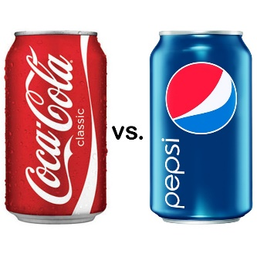
Purpose: This activity will give you a glimpse into the life of a social scientist and help you become more comfortable with the social science inquiry model. You will pair up with a classmate to complete the following tasks. You and your partner will use the age-old Coke vs Pepsi debate to guide you through the stages that define the social science inquiry model.

Step One: Questions
- Identify 3-5 questions that you have about Coca Cola and/or Pepsi:
____________________________________________________________________________________________________________________________________________________________________________________________________________________________________________________________________________________________________________________________________________________________________________________
- Pick one question to be your central research question:
____________________________________________________________________________________________________________________________
Step Two: Focus
- Consider what you already know about your focus area (the topic that you addressed in your central question). List your knowledge below:
__________________________________________________________________________________________________________________________________________________________________________________________________________________________________________________________________________________________________________________________________________________________________________________________________________________________________________________
Step Three: Develop a Hypothesis
- Develop a hypothesis (a possible answer to your central research question): ____________________________________________________________________________________________________________________________
______________________________________________________________
Step Four: Collect Data
- This is the part of the inquiry model where social scientists use one or more research methods to gather information on their chosen topic. Complete the following activities with your partner to develop a stronger understanding of two research methods that are commonly used by social scientists.
- Experiment: Do a taste test with your partner. Have one partner close their eyes while the other partner pours Coke into one cup and Pepsi into another cup. The partner who poured the drinks should have the other partner drink each beverage and identify which beverage they prefer. Note: The partner who poured the drinks should not reveal which one is Coke and which one is Pepsi. Switch roles and complete the experiment again. Afterwards, record each others’ preferences.
- Partner # 1’s preference: ____________
- Partner #2’s preference: ____________
- Survey: With your partner, ask each classmate the following question: In your opinion, which has more sugar – Coke or Pepsi?
- Total number of people surveyed: ______
- Number of people who chose Coke: ______
- Number of people who chose Pepsi: ______
Step Five: Assemble and Analyze Data
- Experiment results: Your teacher will create a t-chart on the board for everyone to see. Each student who preferred Coke (during the experiment) will place a line or checkmark on the left side of the chart. Each student who preferred Pepsi will place a line or checkmark on the right side of the chart. The teacher will then count the total number of students who completed the experiment and write the number on the board. Using this data, calculate:
- the percentage of people who chose Coke: ______ %
- the percentage of people who chose Pepsi: ______ %
- Survey results: Using your survey results, calculate:
- the percentage of people who chose Coke: ______ %
- the percentage of people who chose Pepsi: ______ %
Step Six: We will skip this step today.
Step Seven: Present Results
- Create a pie chart or data table to display one of your results (either the experiment or the questionnaire results). Do this in your notebook.
Step Eight: Reflection
- Identify the rewards and challenges you faced while completing the tasks for this activity. List your ideas in the space provided below.
Rewards: Challenges:

