HSP3U Venn Diagram
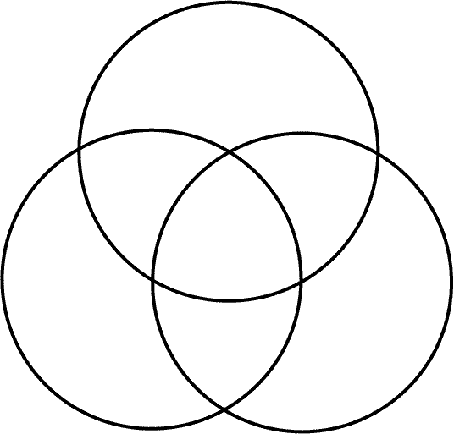
Read p. 5, 7-9, 14-15, 54-55, and 92-93. Next, identify similarities and differences between the three disciplines.
Psychology
Sociology
Anthropology

