HSP3U Monkey Kingdom Assignment

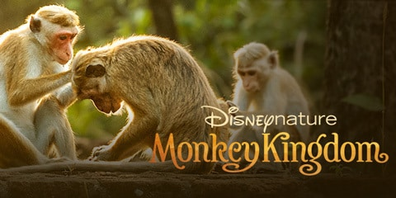
Purpose: We are going to watch Disney’s Monkey Kingdom to better understand the similarities between primates and humans. Over the years, anthropologists and other researchers have determined that there are striking similarities between chimpanzees and humans. This film gives viewers an inside look into the world of chimpanzees.

Your tasks:

- Take notes! Make a chart and list examples of how the chimpanzees are like humans with regard to the following topics:
- Social structures/classes
- Customs and traditions
- Emotions
- Gender norms
- Grooming/self-care practices
- Conflict

- Write a reflection that explores three major similarities between humans and chimpanzees. Follow these guidelines as you write your reflection:
- Ensure that your reflection is double spaced and 2-3 pages in length.
- Begin your reflection with a short introductory paragraph. In this paragraph, you should identify the name of the film and briefly identify the three major connections you intend to establish between humans and chimpanzees.
- Devote a separate paragraph to each connection you establish between humans and chimpanzees. Remember to begin each paragraph with a topic sentence. Support your connections with specific examples from the movie.
- Conclude your reflection by reminding the reader about the main similarities you observed between humans and chimpanzees.

HSP3U Monkey Kingdom Rubric

Criteria | Level 1 | Level 2 | Level 3 | Level 4
Thinking & Inquiry: The student’s rough notes demonstrate that he or she can successfully generate examples that correspond to the curriculum. | -generates examples with limited effectiveness | -generates examples with some effectiveness | -generates examples with considerable effectiveness | -generates examples with a high degree of effectiveness
Communication: The student uses proper spelling, grammar, and punctuation when communicating his or her ideas. | -organizes and expresses knowledge and ideas with limited effectiveness | -organizes and expresses knowledge and ideas with some effectiveness | -organizes and expresses knowledge and ideas with considerable effectiveness | -organizes and expresses knowledge and ideas with a high degree of effectiveness
Application: The student establishes connections between humans and the chimpanzees with a high degree of effectiveness (generating examples). | -makes connections with limited effectiveness | -makes connections with some effectiveness | -makes connections with considerable effectiveness | -makes connections with a high degree of effectiveness

