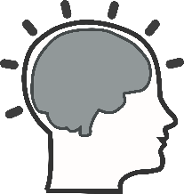
Understanding the Brain

Your task: Read p. 82-89 and complete the following questions.

- To understand the mind, psychologists have increasingly turned to the study of the _______.

- Define neuroscientist:

- What does fMRI allow neuroscientists to do?

- True of False: the brain is only about 2 percent of the average adult’s total body weight.

- Using figure 2-24, draw a sketch of the human brain and then label and briefly explain each part.

- Define cerebrum:

- Define perception:

- True or False: The brain works on a set of assumptions and fills in the gaps by making educated guesses.

- Define perceptual constancy:
- Define perceptual set:

- Psychologists want to explore the brain so they can learn how to ________ human lives.

- Define neuroplasticity:

- What did researchers discover when they studied the brains of Buddhist monks?

- How can meditating help people with Alzheimer’s disease?

- Does yoga have any impact on the brain?

- Identify one brain benefit and one brain burden associated with using the internet.

- A) How did B.F. Skinner believe language development occurs?

B) What did Noam Chomsky argue?

C) What did Elizabeth Bates’ research show?

- Does language affect thought? Explain.

- The existence of a “teenage brain” is a ___________.

- Recent technology seems to reveal that the adolescent brain is in a “____-it-or-______-it” stage of development because the _________-how neurons communicate-that are not used are removed from the brain.

- True or False: Crucial brain development does not occur between the age of 10 to 25.

- Is adolescence a turbulent time for everyone? Explain.

- Define correlation:

