HSP3U Introductory Assignment

Purpose: This assignment will help familiarize you with the ways that anthropologists, psychologists, and sociologists approach trends, issues, and events in our world.

Your tasks:

Part A
- Find one article about a recent trend, issue, or event.
- Summarize the article.
- Your summary should be 250 words min. and in full and complete sentences.
- As you summarize the article, make sure you are answering the 5 W’s and 1 H (eg. Who? What? Where? When? Why? How?).

Part B
- Identify 3 questions you think an anthropologist would ask when examining the trend, issue, or event and then explain why you think these questions are associated with anthropology (in approx. 1 paragraph).
- Identify 3 questions you think a psychologist would ask when examining the trend, issue, or event and then explain why you think these questions are associated with psychology (in approx. 1 paragraph).
- Identify 3 questions you think a sociologist would ask when examining the trend, issue, or event and then explain why you think these questions are associated with sociology (in approx. 1 paragraph).

*Note: Please include a copy of the article with your assignment.

Due date: _____________________

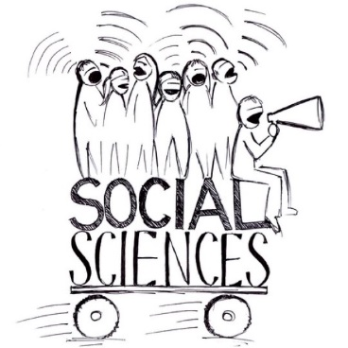

Rubric

 | Level 1 | Level 2 | Level 3 | Level 4
Knowledge & Understanding:  The article summary demonstrates a strong understanding of the trend, issue, or event. | -demonstrates limited knowledge of the selected trend, issue, or event | -demonstrates some knowledge of the selected trend, issue, or event | -demonstrates considerable knowledge of the selected trend, issue, or event | -demonstrates thorough knowledge of the selected trend, issue, or event
Thinking & Inquiry: The student develops questions that demonstrate strong evidence of critical thinking. | -creates few thought-provoking and appropriate questions for each discipline | -creates some thought-provoking and appropriate questions for each discipline | -creates thought-provoking and appropriate questions for each discipline with considerable effectiveness | -creates thought-provoking and appropriate questions for each discipline with a high degree of effectiveness
Communication: The student uses proper spelling, grammar, and punctuation. The student also organizes his or her ideas effectively. | -expresses and organizes knowledge & ideas with limited effectiveness | -expresses and organizes knowledge & ideas with some effectiveness | -expresses and organizes knowledge & ideas with considerable effectiveness | -expresses and organizes knowledge & ideas with a high degree of effectiveness
Application: The student applies his or her knowledge of the social sciences with a high degree of effectiveness when creating and justifying his/her question choices. | -applies knowledge of the three disciplines with limited effectiveness | -applies knowledge of the three disciplines with some effectiveness | -applies knowledge of the three disciplines with considerable effectiveness | -applies knowledge of the three disciplines with a high degree effectiveness

Descriptive feedback:

