Prohibition

Your task: Read page 87-88 in your textbook and answer the following questions.

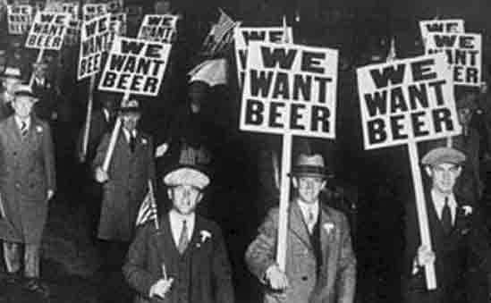
- What was the temperance movement?

- What is prohibition?

- What were some of the positive outcomes that prohibition supporters hoped to see?

- True or False: The federal government does not have control over the manufacturing, importation, and export of alcohol.

- Who has control over the sale and consumption of alcohol?

- What was the name of the province that never had prohibition?

- Which province had prohibition for the longest time?

- What were some of the advantages to prohibition?

- True or False: Prohibition lasted longer in the United States.

Bootlegging in Windsor, Ontario

Your task: Read the article, “Bootlegging in Windsor, Ontario,” and answer the following questions. *Use a classroom dictionary or electronic device to find the terms.

- Using a dictionary or your phone, look up the following words:
Bootlegging:
Rumrunner:
Speakeasy:

- What did people use the Detroit River for during the prohibition era?

- What were some the other ways that bootleggers smuggled alcohol?

- Although Ontario had _________ the retail sale of liquor, the federal government approved and licensed __________ and breweries – of which there were 45 in Ontario alone in ______ - to manufacture, distribute, and export.

- A) Who was The Purple Gang?

B) How was The Purple Gang connected to bootlegging?

- Based on what you have learned, do you think prohibition was a success or failure? Explain.

