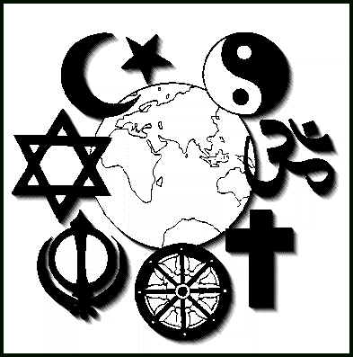
World religions: A Canadian Catholic Perspective
Reading Comprehension Questions
Chapter 1 – World Religions and Religious Pluralism

Read pp. 2-28 and respond to the following questions in your notebook.
RELIGIOUS PLURALISM IN CANADA
- Identify two factors that have helped to make Canada a diversity of cultures and faiths.
- Define multicultural.
- Define multiculturalism.
- What does Canada’s policy of multiculturalism mean?
HISTORY OF RELIGIOUS PLURALISM
- Define religious pluralism.
- As of 2001, what percentage of Canadians identified themselves with the Christian faith?
THE GOALS OF DIALOGUE
- Why must our relationship with other religions go beyond tolerance?
- What lessons can we take away from The Parable of the Weeds among the Wheat?
CATHOLICS AND OTHER RELIGIONS IN THE TWENTIETH AND EARLY TWENTY-FIRST CENTURIES
- Why do Catholics believe that all human beings can be saved, even if they are not baptized?
- Define salvation.
- Do Catholics believe that Christ is present in other religions? Explain.
- Why must Catholics never hide their faith in Christ?
- Explain the role of the Holy Spirit in the Catholic faith. How is the Spirit active in other religions?

